|  |  |  |
| --- | --- | --- |
| SCHOOL OF INFORMATION AND TECHNOLOGY | | |
| NAME: Bartolome, Brylle  Caccam, Jesus Allyson | DATE PERFORMED: Nov 28, 2024 | /50 |
| Section: IDC2 | DATE SUBMITTED: Dec 3, 2024 |

# SYSADM1 – Capacity Management & Planning

**Part 2. Network Scalability Analysis**

Recall the e-commerce website scenario we discussed earlier. Given the expected surge in traffic, analyze the provided network topology diagram. Identify potential bottlenecks and areas where scalability might be a concern. Propose specific strategies to improve the network's scalability and performance to ensure a seamless user experience during the peak traffic period. Consider factors such as increased user demand, new applications, and security threats.

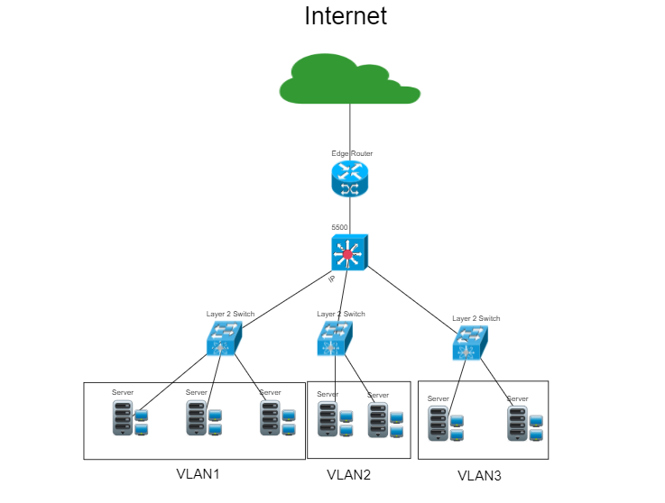

**Bottlenecks:**

1. **Single Firewall**: All VLAN traffic is routed through a single firewall, which can create a significant bottleneck during peak usage times.
2. **Layer 2 Switches**: The current Layer 2 switches lack inter-VLAN routing capabilities. This limitation forces all inter-VLAN traffic to pass through the firewall or a Layer 3 device, which can lead to overload.
3. **Edge Router**: As traffic increases, the edge router may struggle to efficiently manage external requests.

**Capacity Limitations:**

1. **Server Allocation per VLAN:** Each VLAN has a limited number of servers. During high-traffic periods, this can hinder the VLAN's ability to manage increased user requests.
2. **Bandwidth:** The uplink bandwidth between switches, the firewall, and the edge router is insufficient, potentially causing network congestion.

**Security Risks:**

1. **Flat VLAN Structure**: The lack of segmentation beyond VLANs can expose sensitive data if one VLAN is compromised.
2. **Firewall Overload**: Relying on a single firewall creates a point of failure that could result in downtime during traffic spikes.
3. **No Redundancy**: The absence of redundant connections or devices could lead to significant downtime if any component fails.

#### **Addressing Bottlenecks**

* **Upgrade to Layer 3 Switches**: Replace Layer 2 switches with Layer 3 switches to handle inter-VLAN routing internally, reducing the load on the firewall.
* **Load Balancer Deployment**: Introduce load balancers to distribute traffic across multiple servers within VLANs to prevent overloading any single server.
* **High-Capacity Firewall**: Upgrade the firewall to a model with higher throughput capacity or deploy multiple firewalls in an active-active configuration.

**Drawbacks**:

* Increased costs due to hardware upgrades.
* Complexity in configuring and maintaining load balancers and multiple firewalls.

#### **Improving Scalability**

* **Bandwidth Upgrades**: Increase the uplink bandwidth between switches, the firewall, and the router to accommodate higher traffic volumes.
* **Vertical and Horizontal Server Scaling**:
  + Vertical Scaling: Add resources (RAM, CPU) to existing servers.
  + Horizontal Scaling: Add more servers to each VLAN and configure clustering for better load distribution.
* **Cloud Integration**: Use cloud services (e.g., AWS, Azure) to handle overflow traffic during peak times.
* **Redundant Links and Devices**: Implement redundant connections and devices to ensure high availability.

**Drawbacks**:

* Cost considerations for additional hardware or cloud services.
* Cloud reliance might introduce latency for some applications.

#### **Enhancing Security**

* **Segmentation with ACLs**: Apply Access Control Lists (ACLs) and policies at Layer 3 switches for stricter inter-VLAN communication controls.
* **Redundant Firewalls**: Deploy a secondary firewall for failover.
* **DDOS Protection**: Use DDOS mitigation services or appliances to protect against traffic surges from attacks.

**Drawbacks**:

* Security measures might introduce latency or additional complexity.
* Firewall redundancy increases hardware costs.

To enhance the network's scalability, we should deploy Layer 3 switches with 10Gbps uplink ports and a next-generation firewall that supports at least 10 Gbps throughput. Utilizing routers with advanced queuing mechanisms will help manage traffic spikes effectively. On the software side, implementing Quality of Service (QoS) will prioritize critical traffic, while enabling VLAN tagging (802.1Q) will improve organization. Additionally, using dynamic routing protocols like OSPF or BGP can speed up routing processes. To reduce server load, a Content Delivery Network (CDN) can cache static content closer to users. Finally, monitoring tools like Nagios or SolarWinds should be employed to track network performance and quickly identify issues.

**Proposed Network Design**

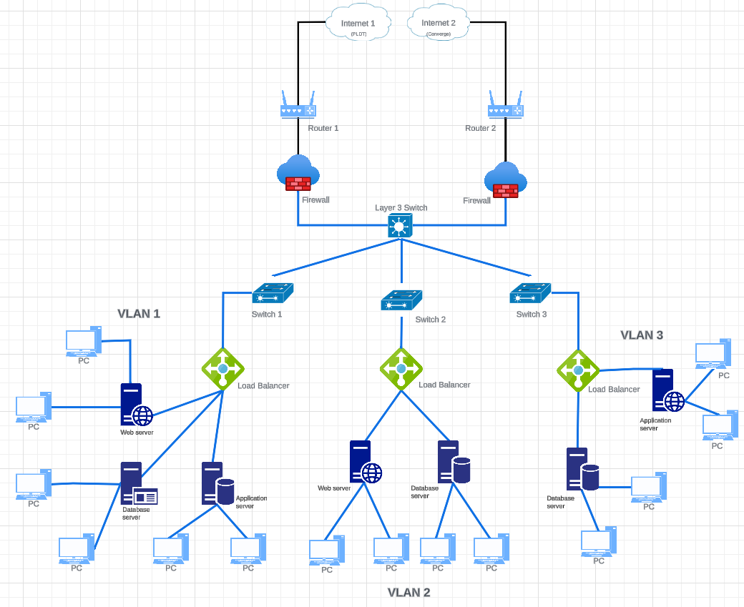

**Evaluating the Plan:**

1. **Cost:**

**Upgrading hardware is expensive, but it’s a good investment for future growth.**

**Cloud services can help save money initially but might add up over time.**

1. **Complexity:**

**Managing new devices like load balancers and advanced firewalls will require training. Setting up the new system might take some time.**

1. **Impact:**

**These upgrades will make the network faster and more reliable. It’ll handle more traffic and be more secure against attacks.**

|  |  |  |  |
| --- | --- | --- | --- |
| Criteria | Excellent | 10pts | Good | 7pts | Needs Improvement | 4pts |
| **Network Analysis** | Accurately identifies potential bottlenecks, security risks, and capacity limitations. | Identifies key network components and some potential bottlenecks. | Identifies some basic network components but lacks a comprehensive analysis. |
| **Scalability Planning** | Proposes multiple relevant solutions and provides detailed explanations, including potential drawbacks and benefits. | Proposes some relevant scalability strategies but lacks detail. | Proposes limited scalability strategies. |
| **Evaluation of Solutions** | Proposes comprehensive scalability strategies, including specific recommendations for hardware upgrades, software configurations, and network optimizations. | Provides a basic evaluation of the proposed solutions, but lacks depth. | Does not evaluate the proposed solutions or provides a superficial evaluation. |
| **Proposed Design** | Provides a detailed and well-justified design, including network diagrams, configuration details, and implementation plans. | Provides a basic design but lacks specific details and justifications. | Does not provide a clear and detailed design. |
| **Evaluation and Justification** | Provides a thorough evaluation of the proposed solutions, considering factors like cost, complexity, and potential impact. | Provides a basic evaluation of the proposed solutions, but lacks depth. | Does not evaluate the proposed solutions or provides a superficial evaluation |
| Score: | | | /50 |

References:

GeeksforGeeks, “Inter VLAN routing by Layer 3 switch,” *GeeksforGeeks*, May 02, 2023. Available: <https://www.geeksforgeeks.org/inter-vlan-routing-layer-3-switch/>

“Inter-VLAN routing: configuration examples.” Available:

<https://www.catchpoint.com/network-admin-guide/inter-vlan-routing>

GeeksforGeeks, “Packet queuing and dropping in routers,” *GeeksforGeeks*, Jul. 06, 2022. Available: <https://www.geeksforgeeks.org/packet-queuing-and-dropping-in-routers/>